**IRT Setup/ Installation**

**Installation tools:**

* 1 3/4" flight auger
* Impact driver
* 5/16” magnetic nut driver

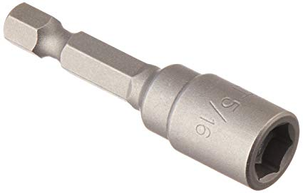

* Hammer/mallet
* Long PVC for adjusting sensor angle (¾” or 1” work well)

**Installation Materials:**

* #12 x ½” self-driving screws
* Washer (1/4")
* Green stakes
* Zip ties (to attach enclosure)
* Battery Enclosure
* 12V battery
* Charge controller
* Solar panel and mount
* Desiccant packs

**Installation Instructions:**

1. Wire canopy sensor cable through PVC structure and attach all PVC parts:

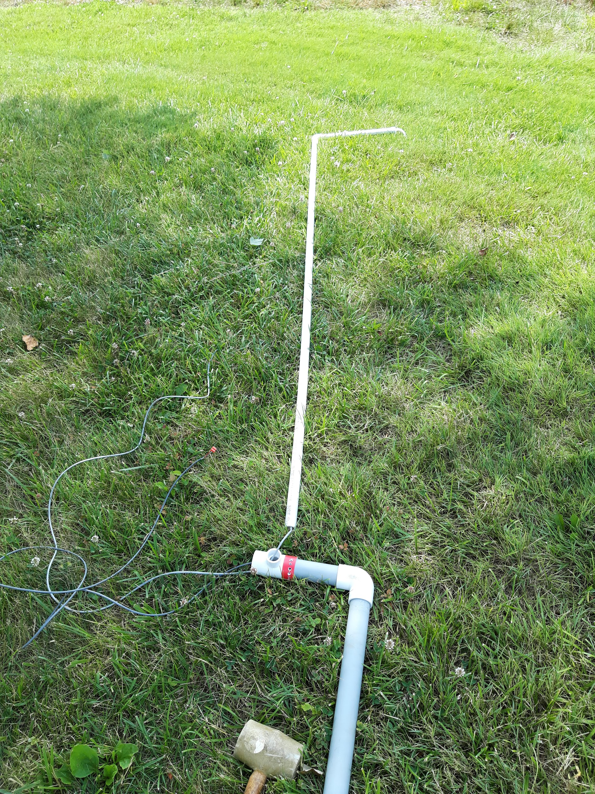

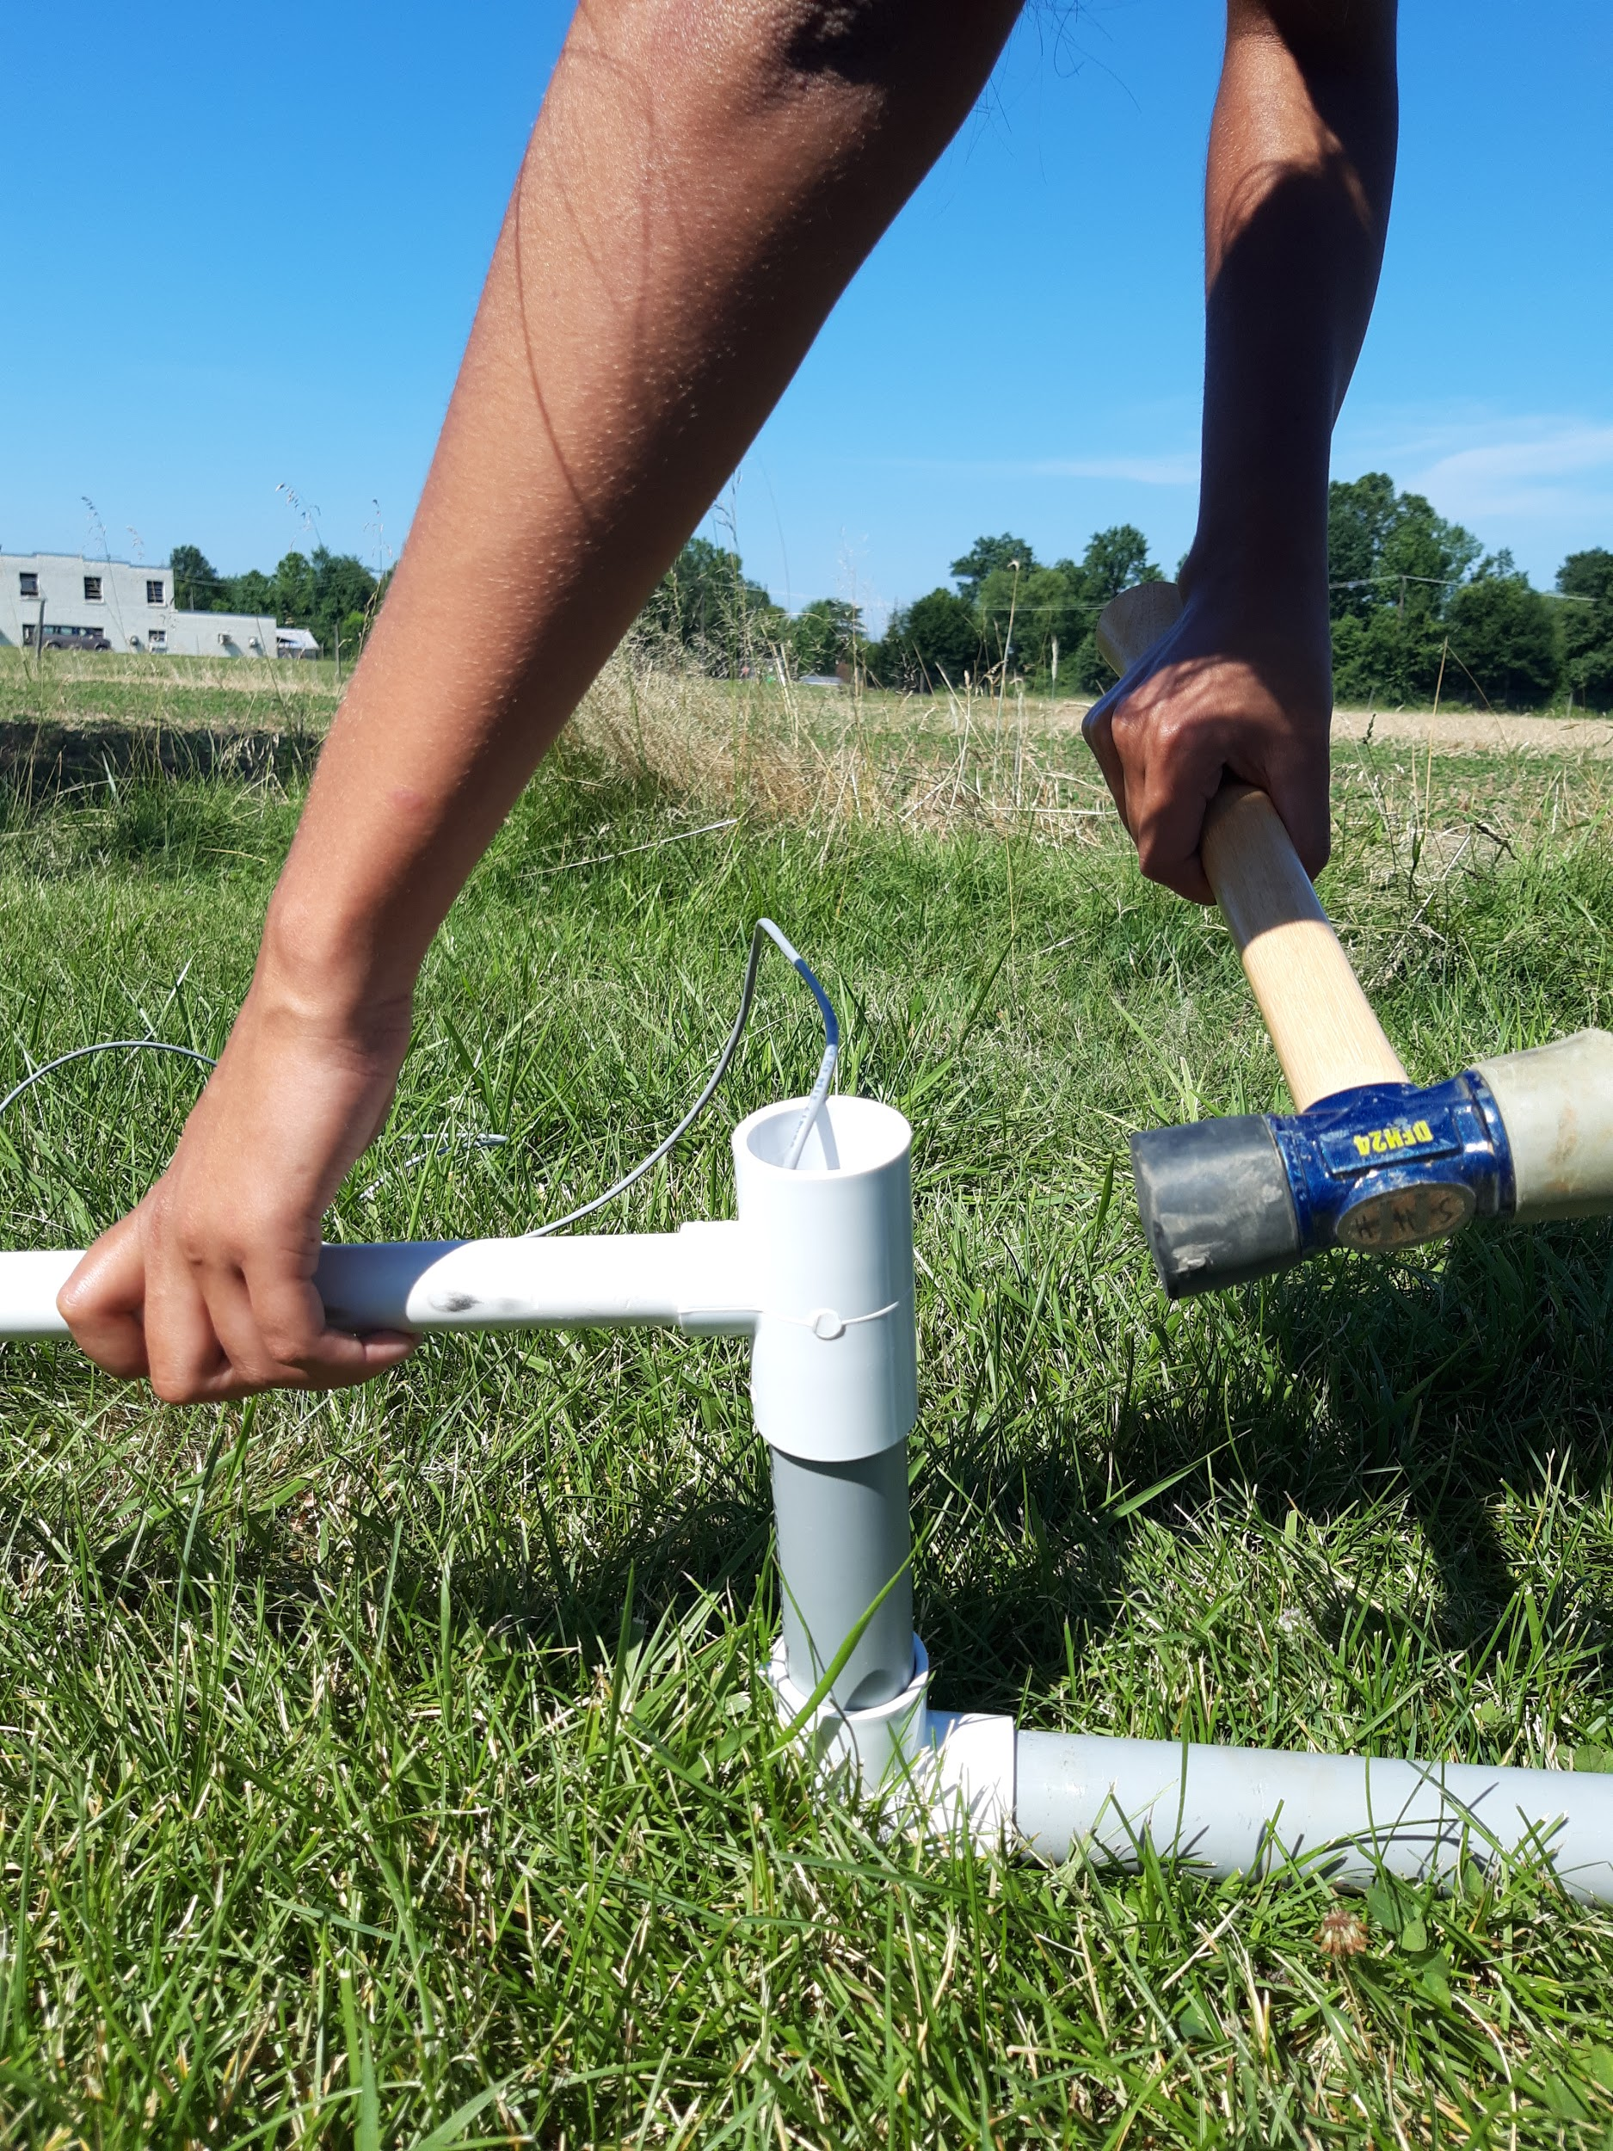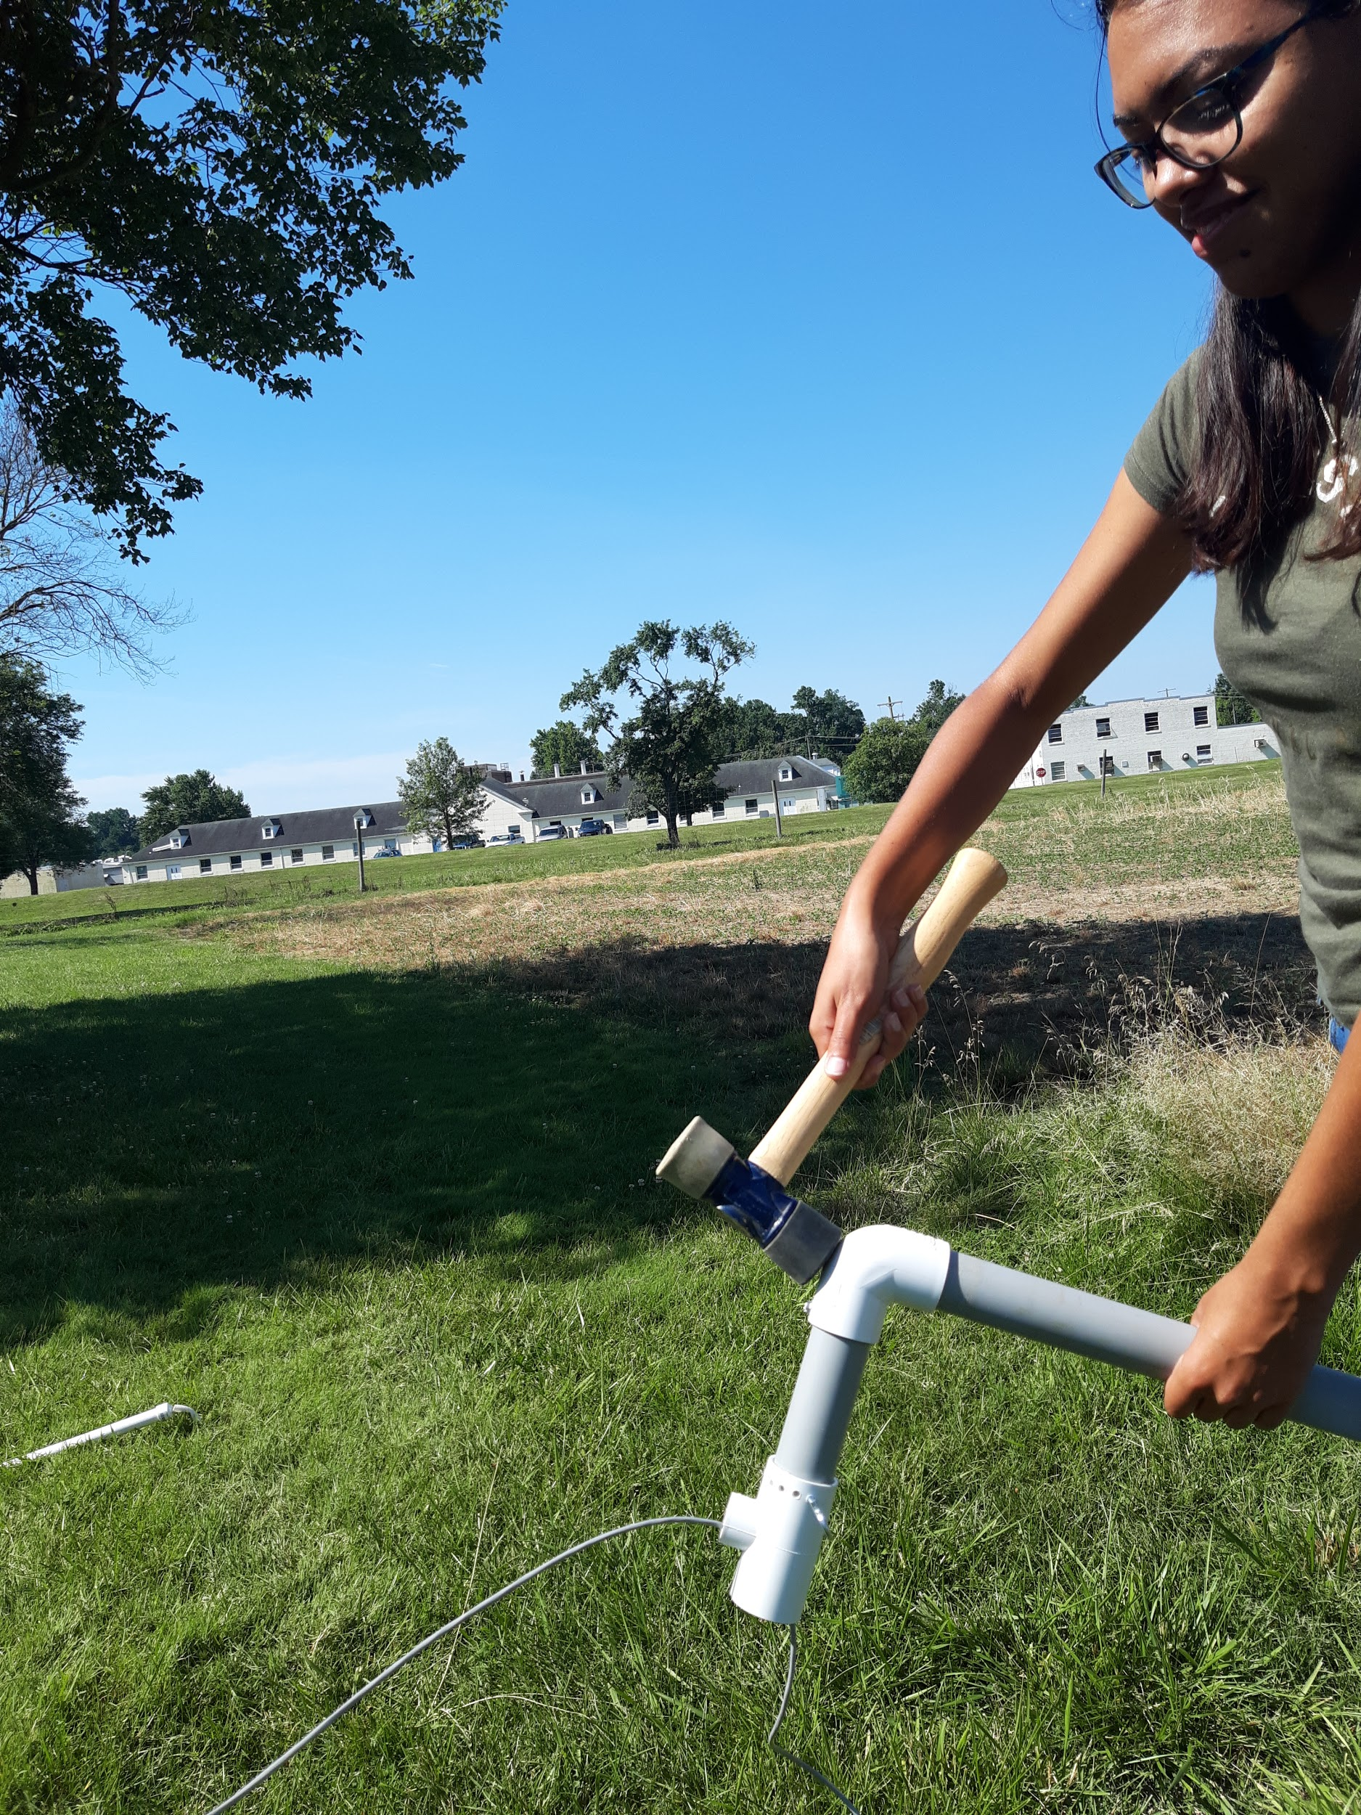

1. Use hammer or mallet to ensure pivot T-PVC is completely hammered into gray PVC before inserting hook screw pin

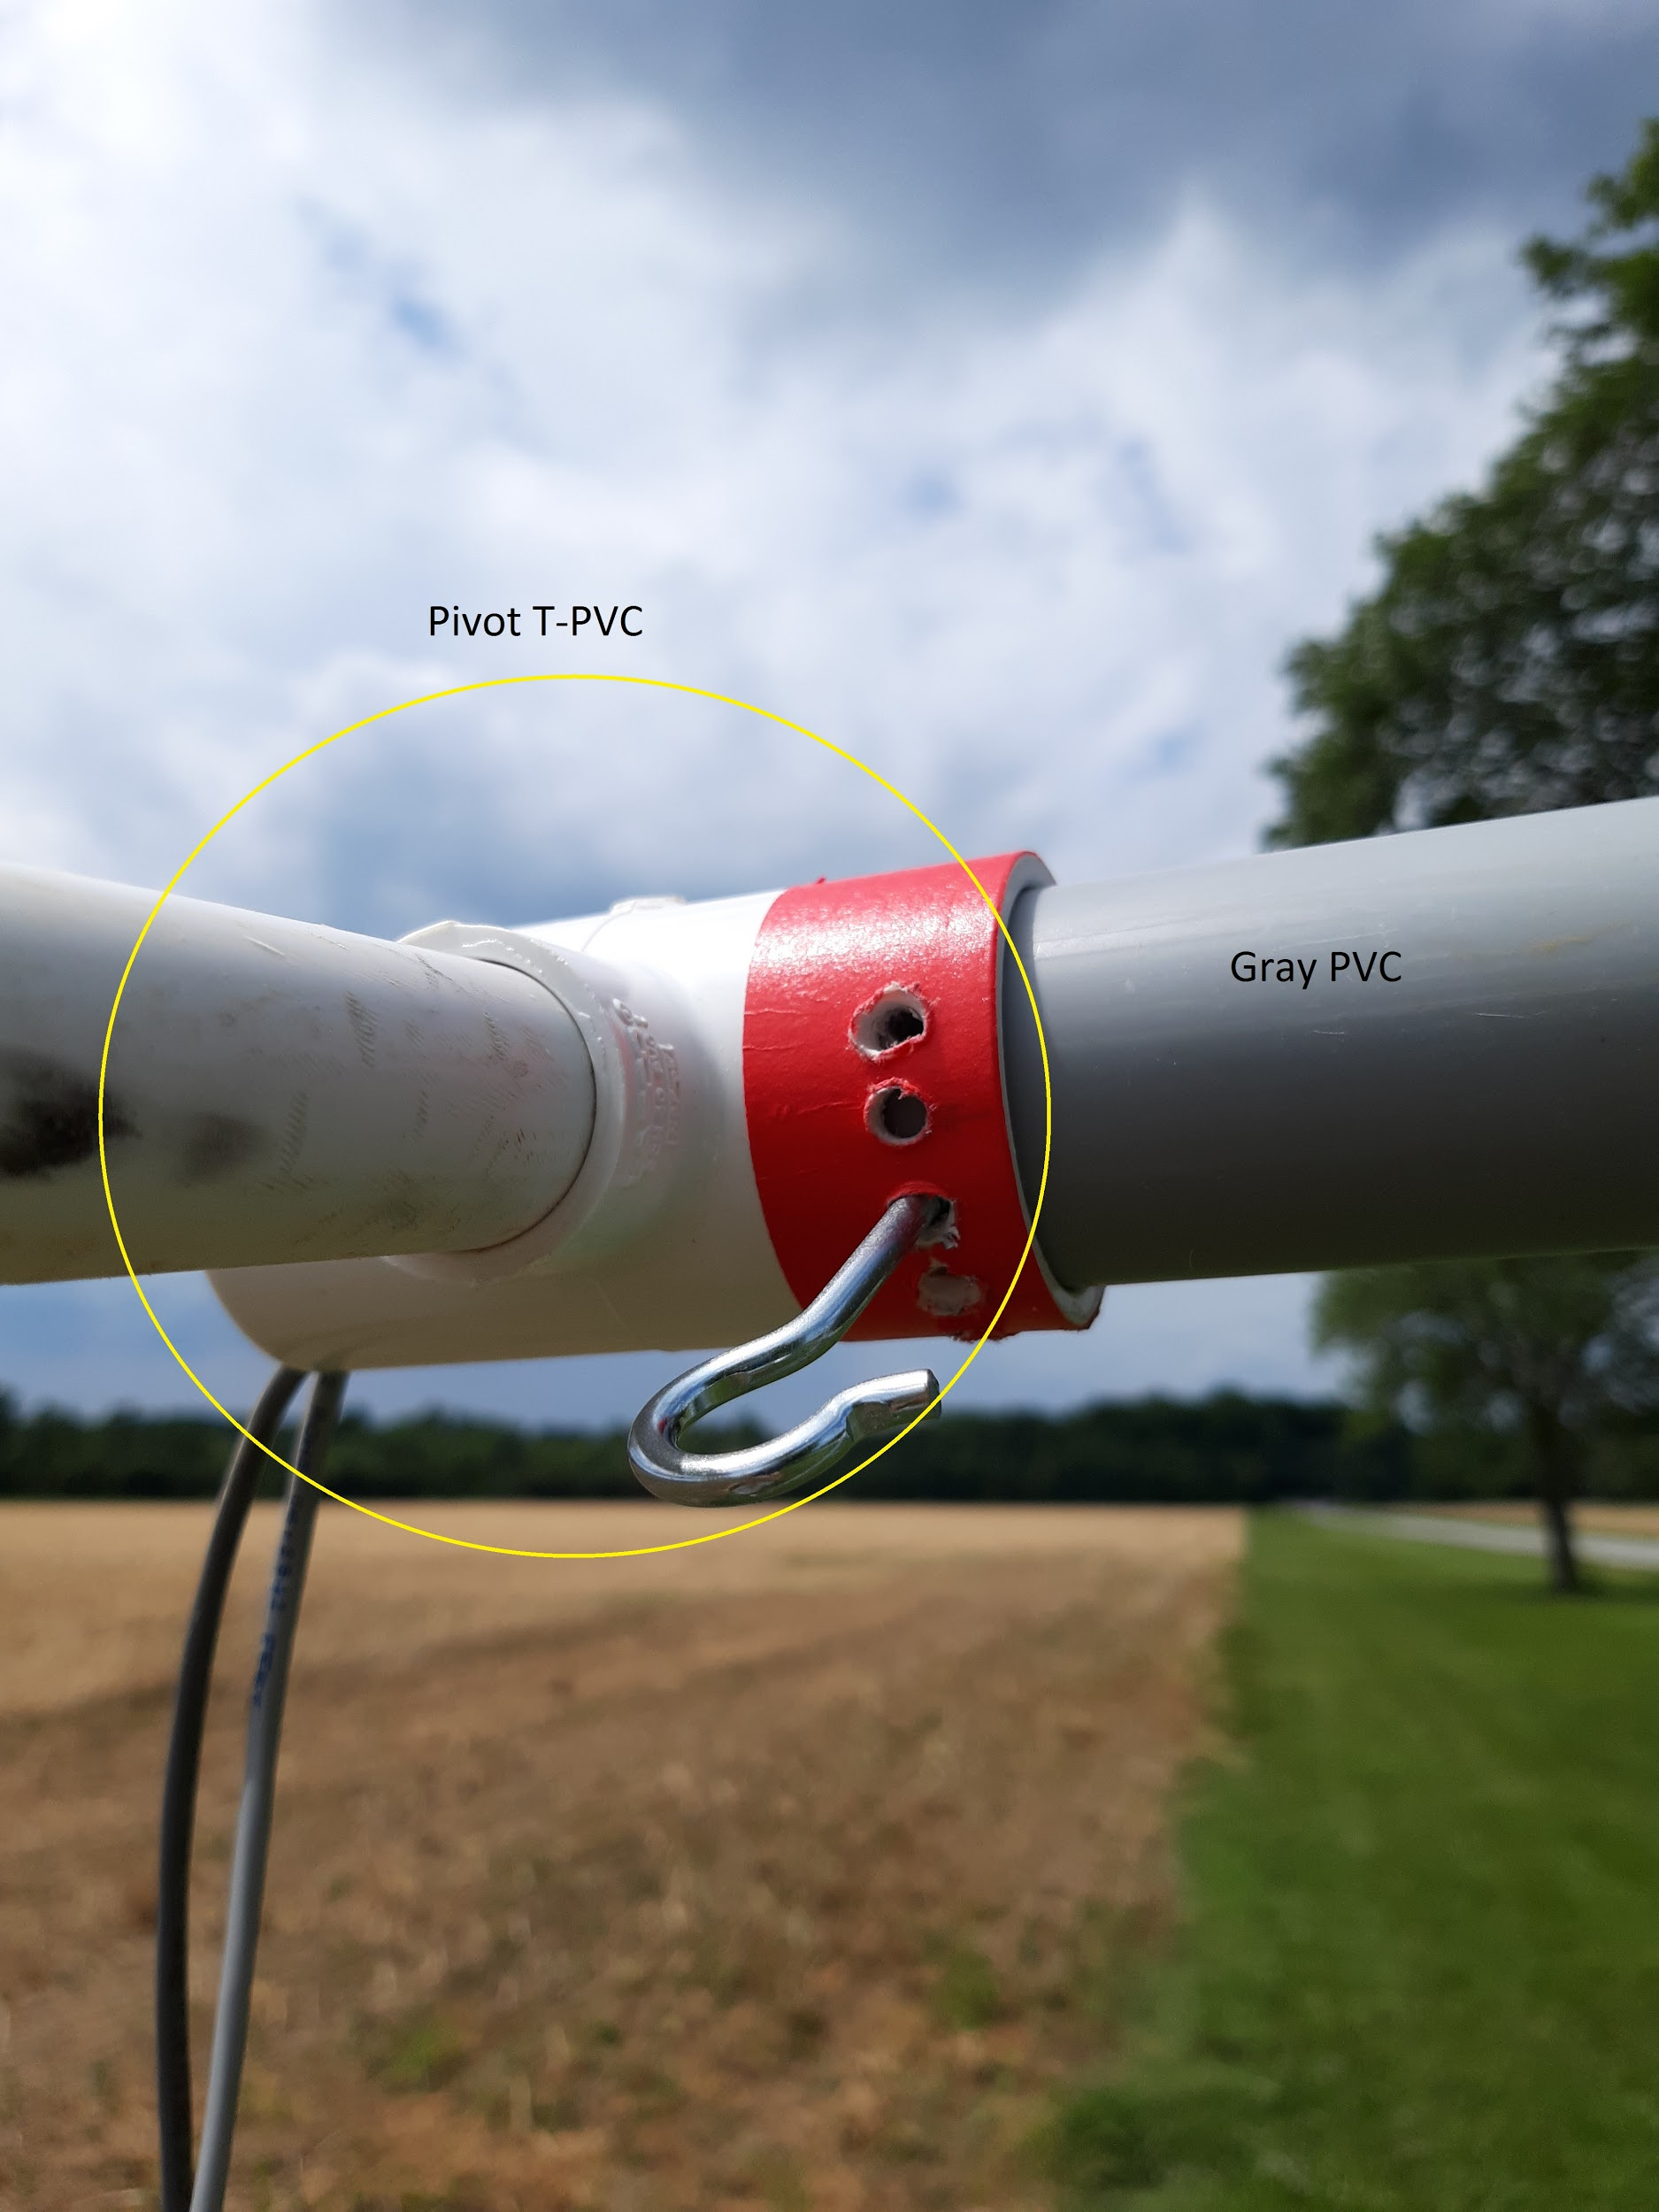

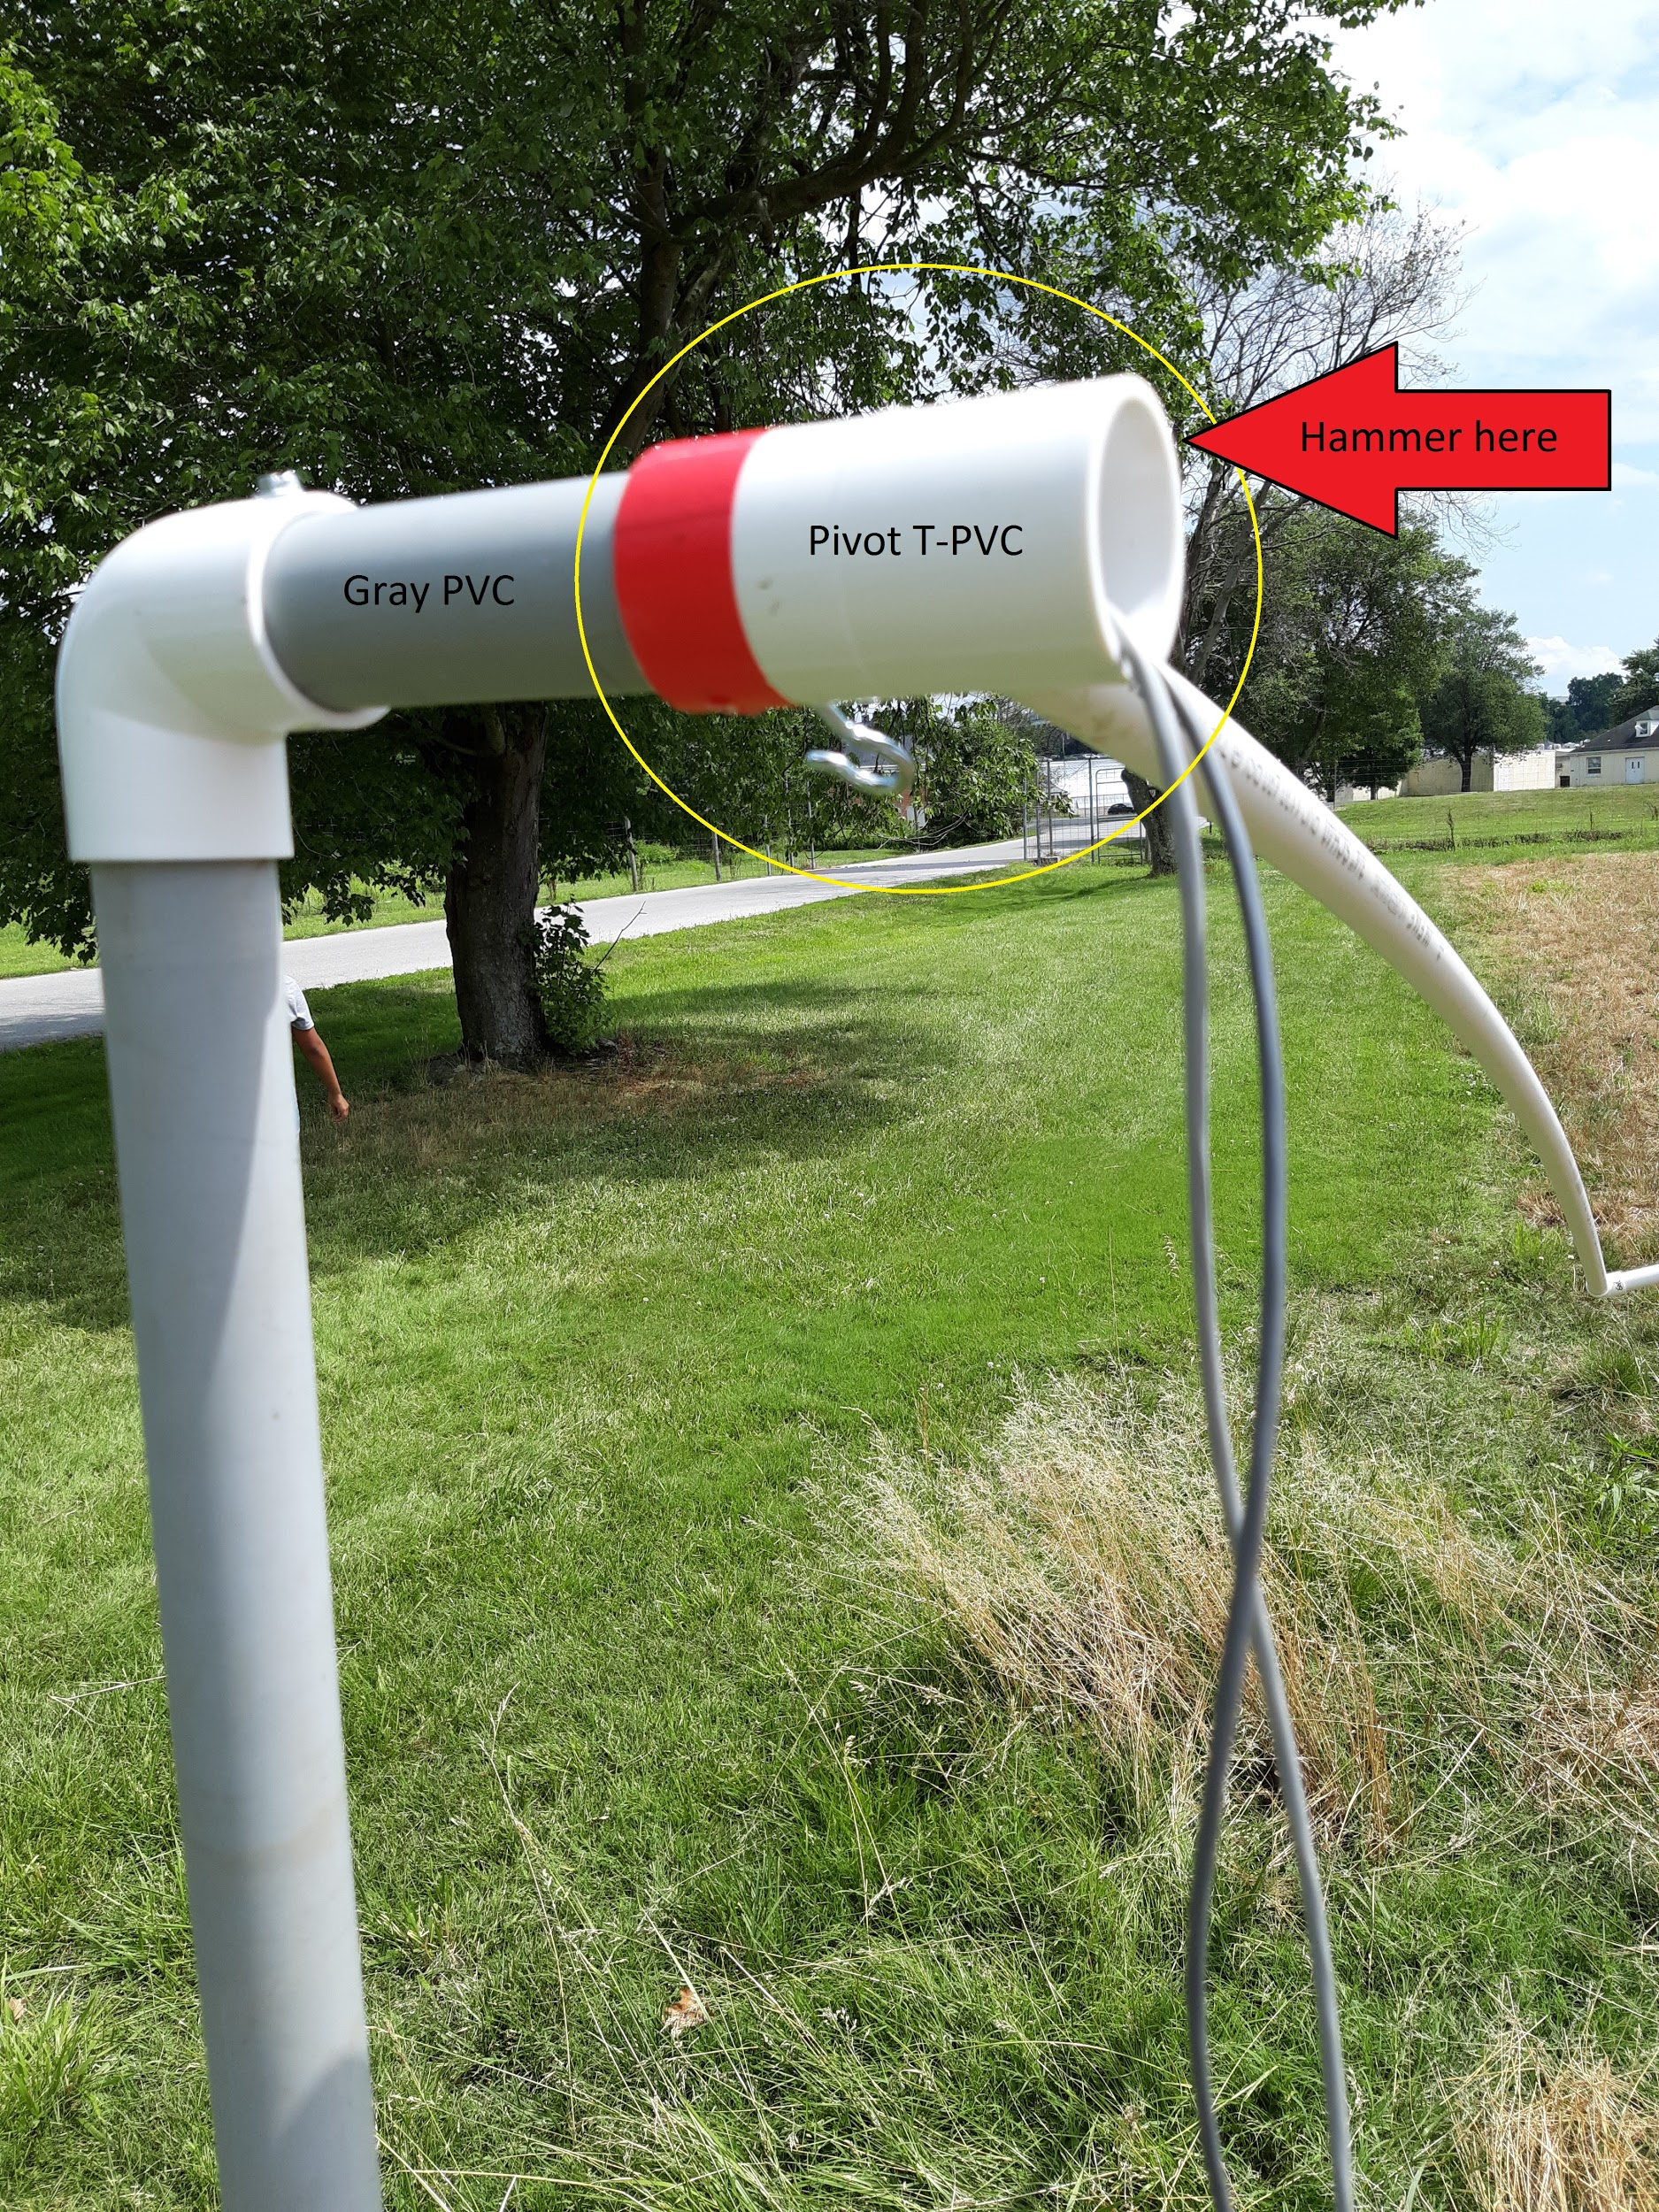

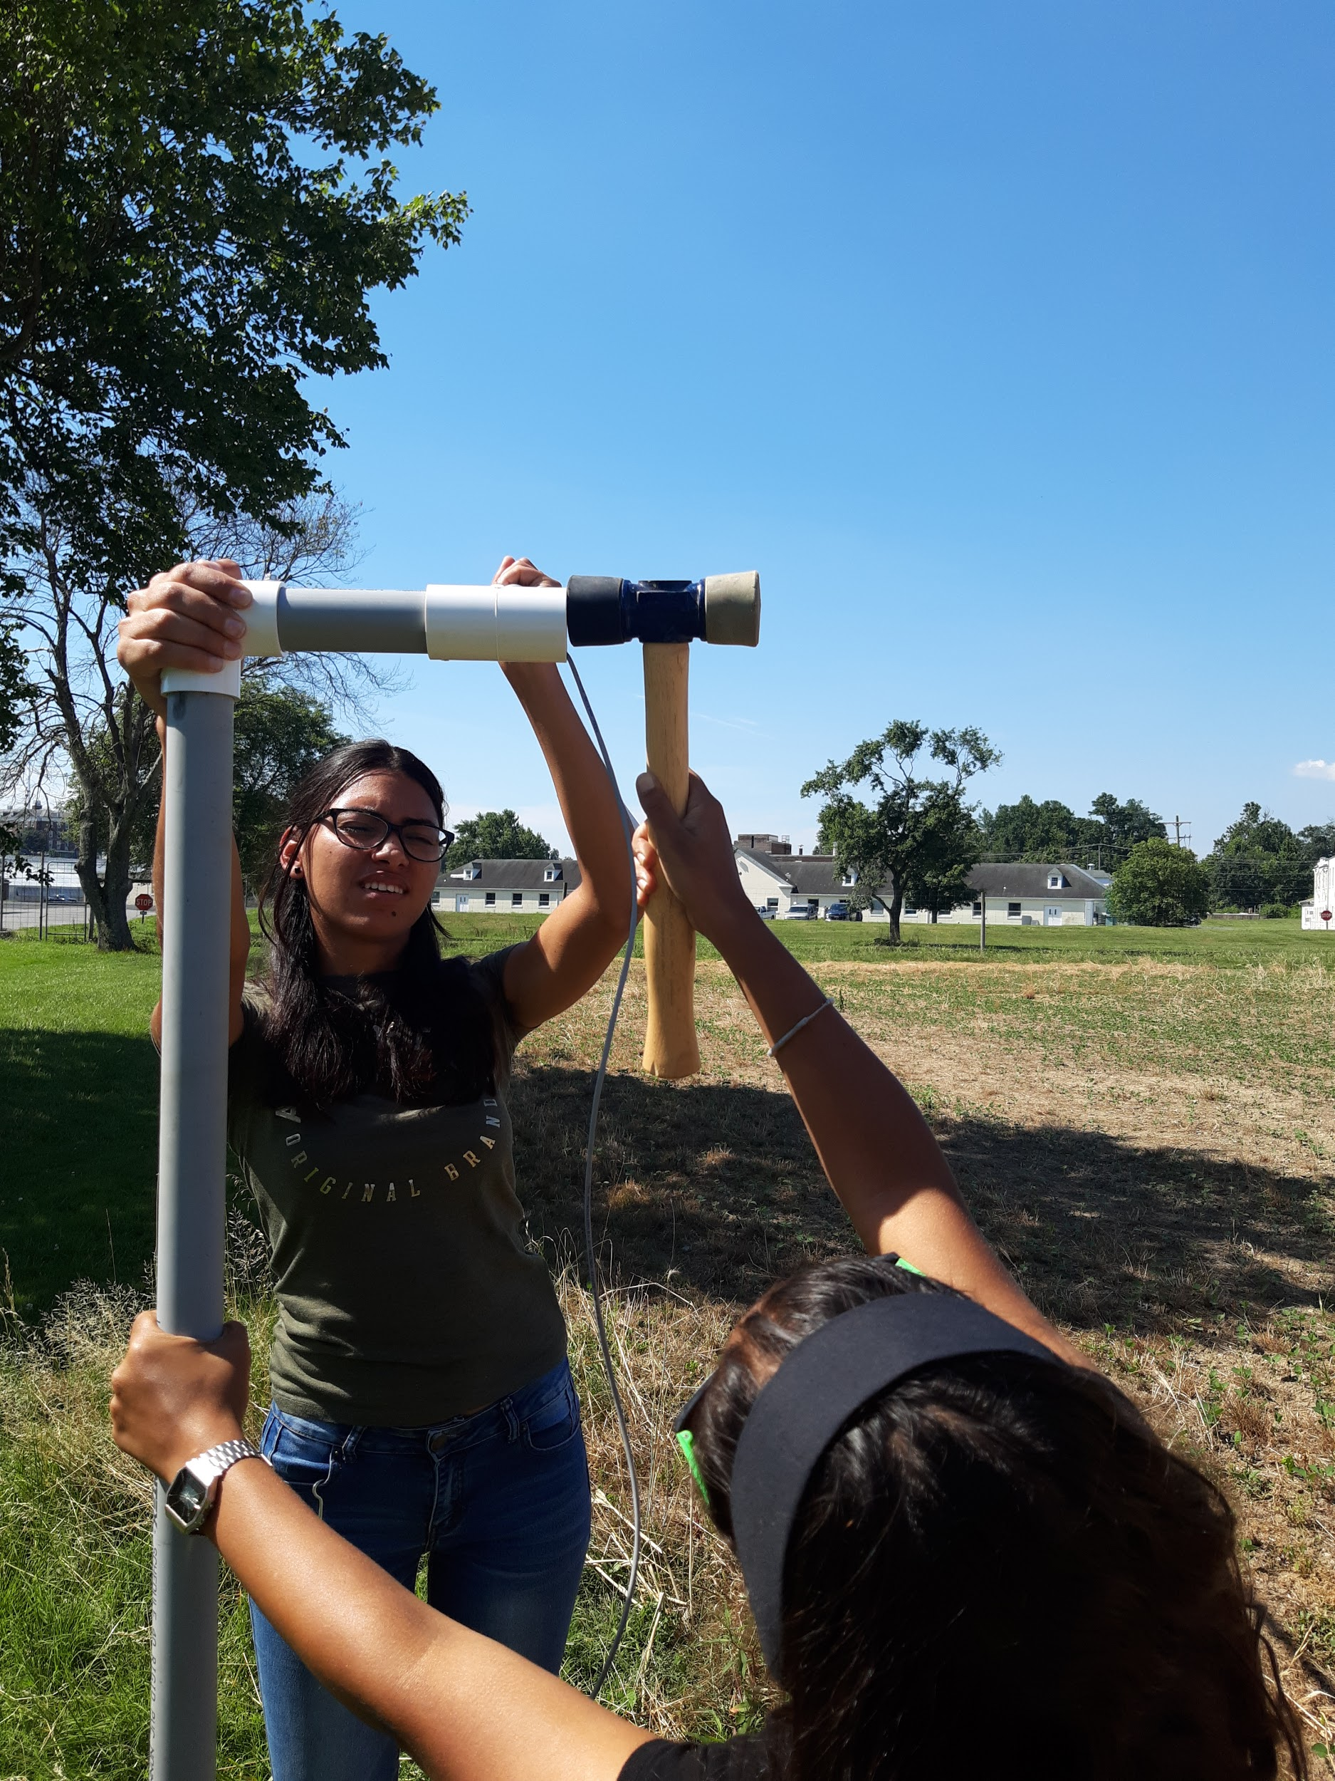

1. Place 5’ metal pole inside main post of IRT structure for stability
2. Attach green stakes about 2.5’ from bottom of gray PVC using ¼” washer and #12 self-driving screw as pictured below. (Note: we had a little bit of difficulty with this. What seemed to work best was using an impact driver at a slow speed while applying pressure (in order to avoid stripping the PVC). We originally planned to use a ⅜” washer and a ¼” washer, but found that using the ¼” washer alone was sufficient.)

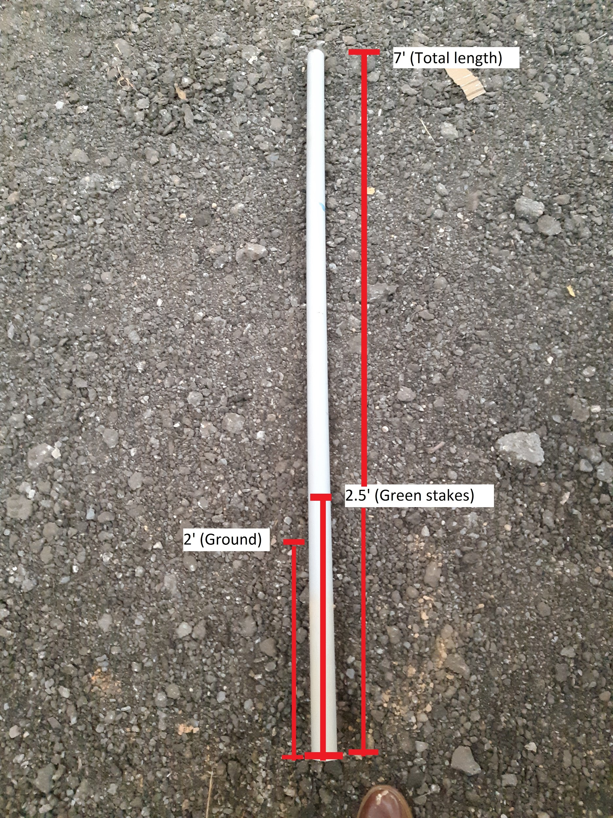

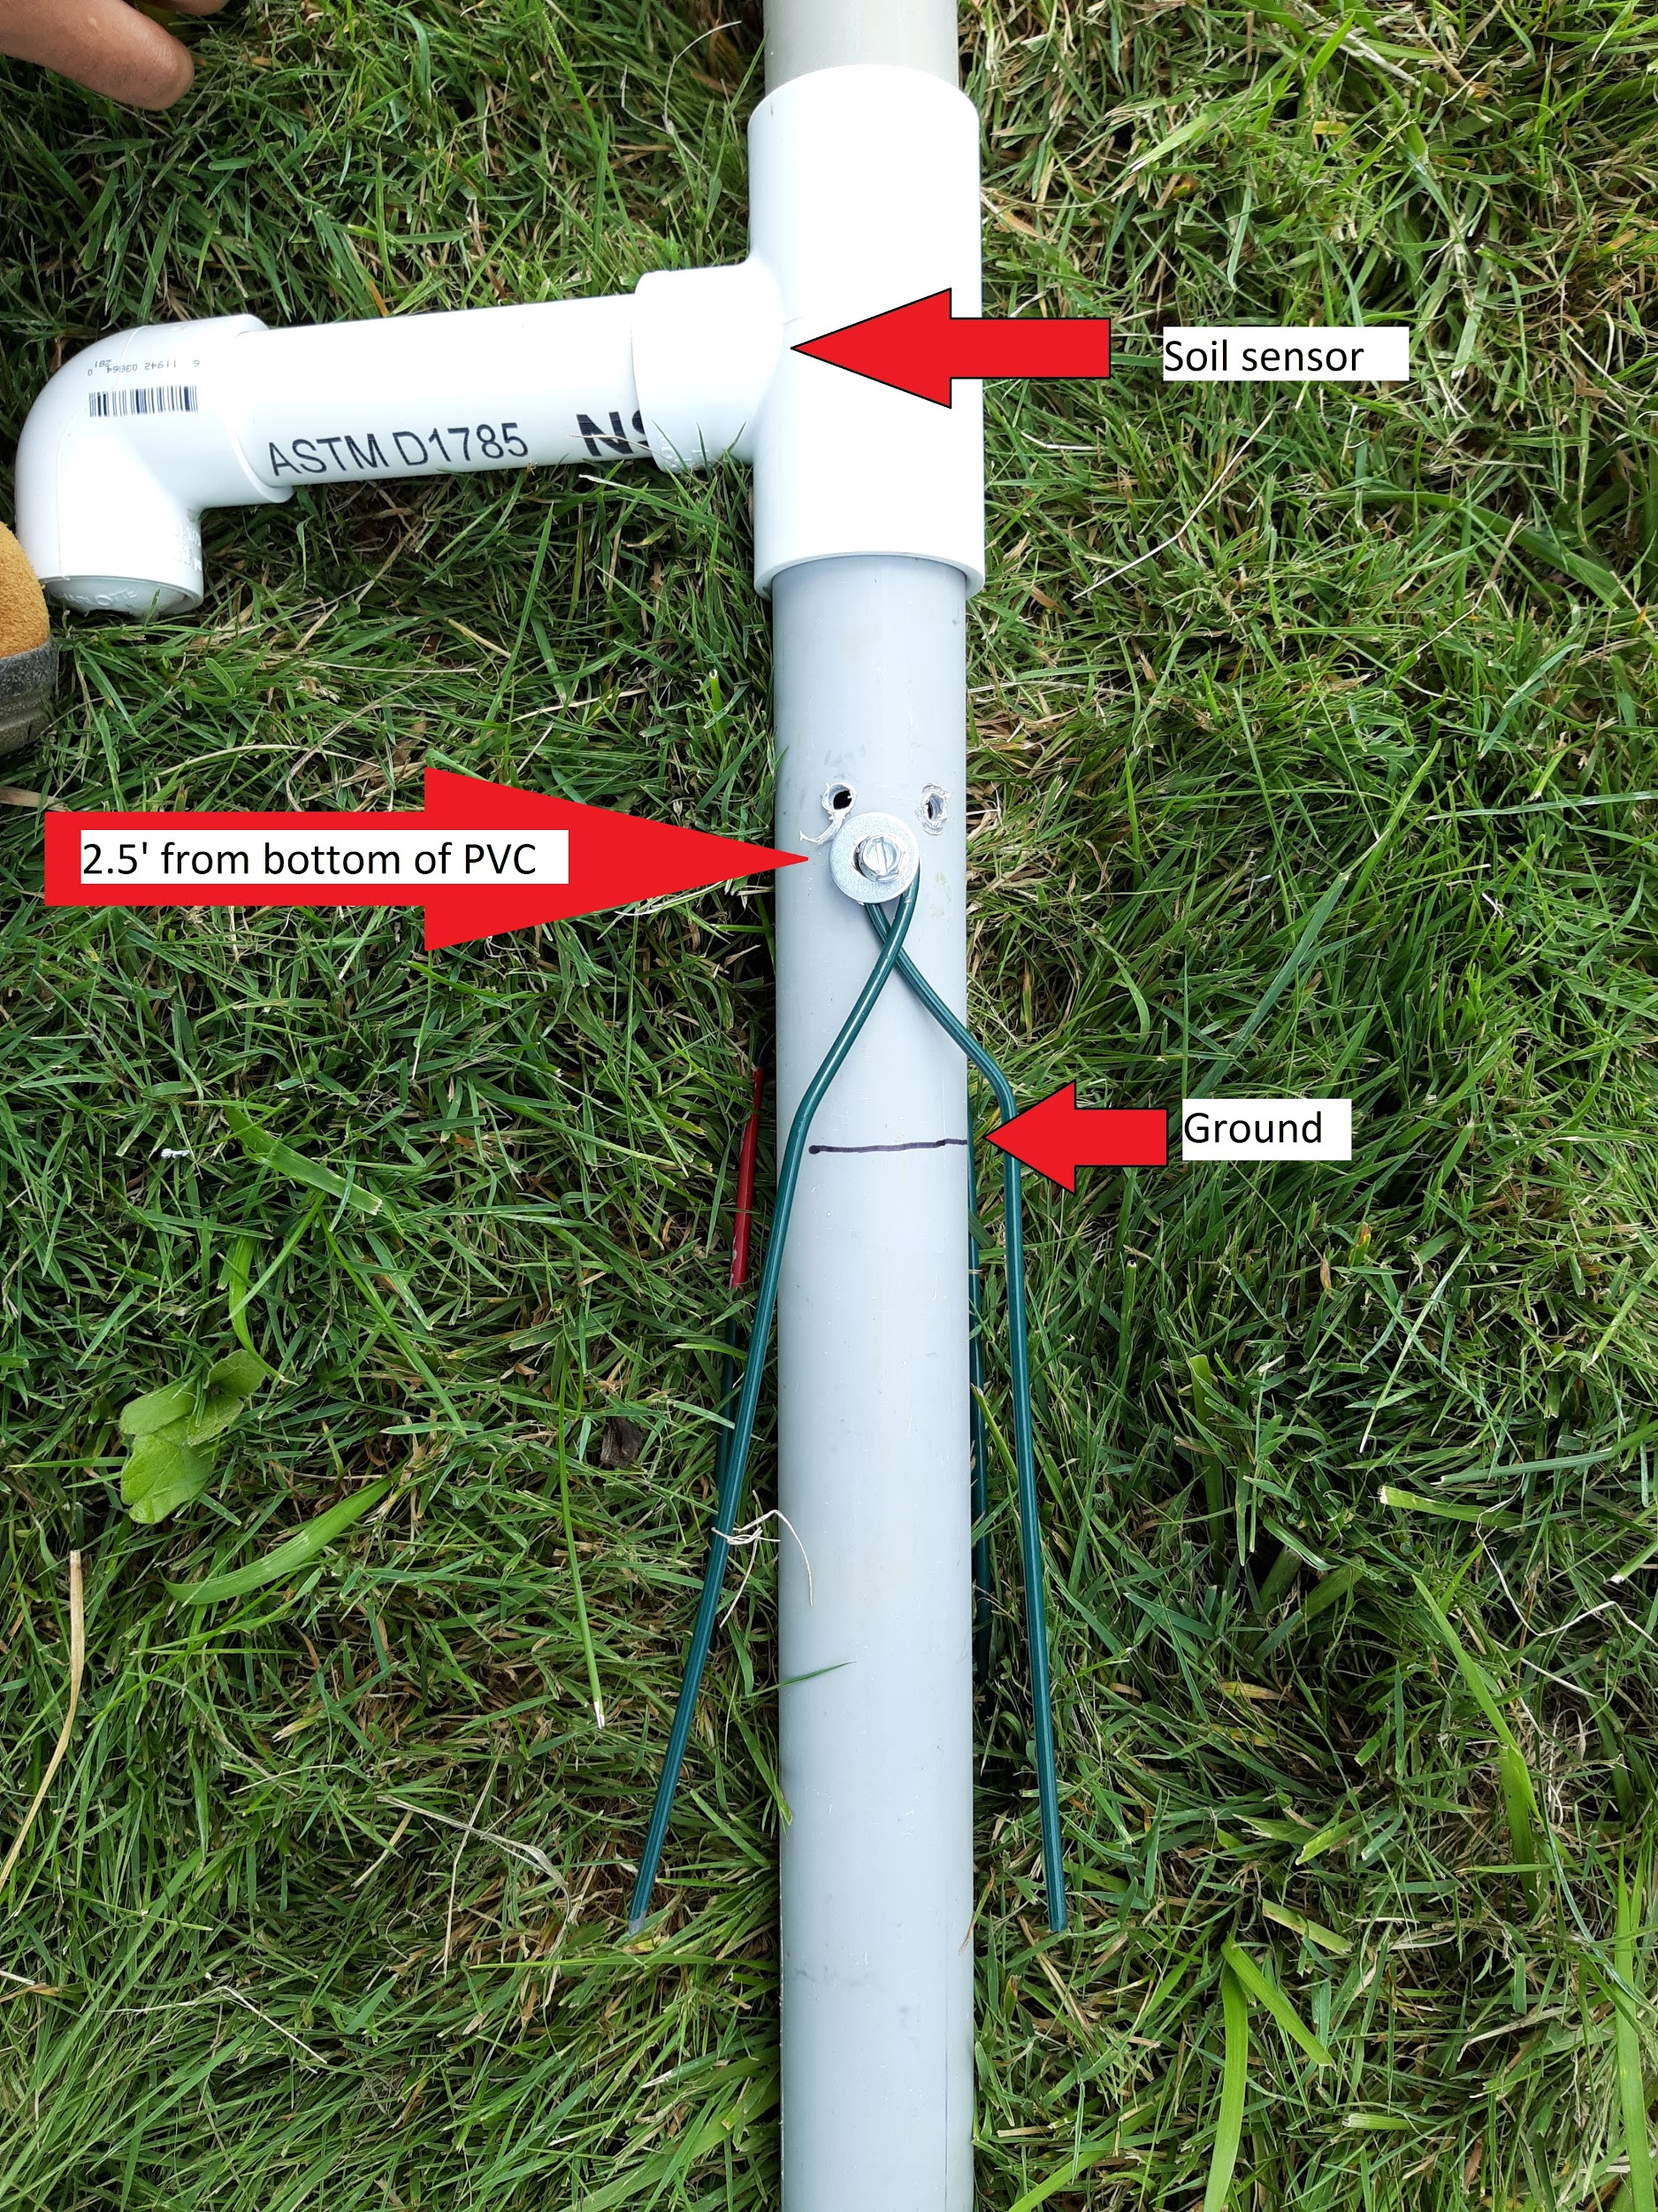

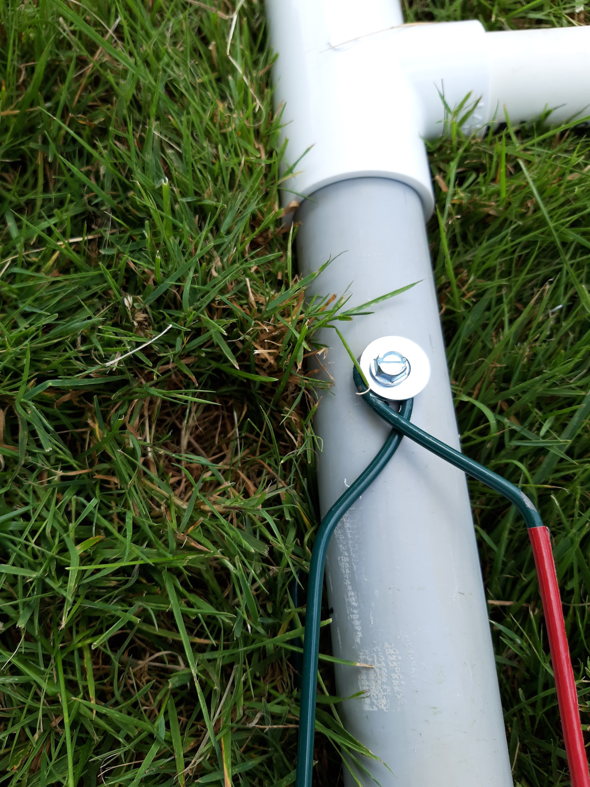

1. Auger hole ~2’ deep
2. Rotate structure to desired orientation and place in augered hole (ensuring green stakes insert into ground)

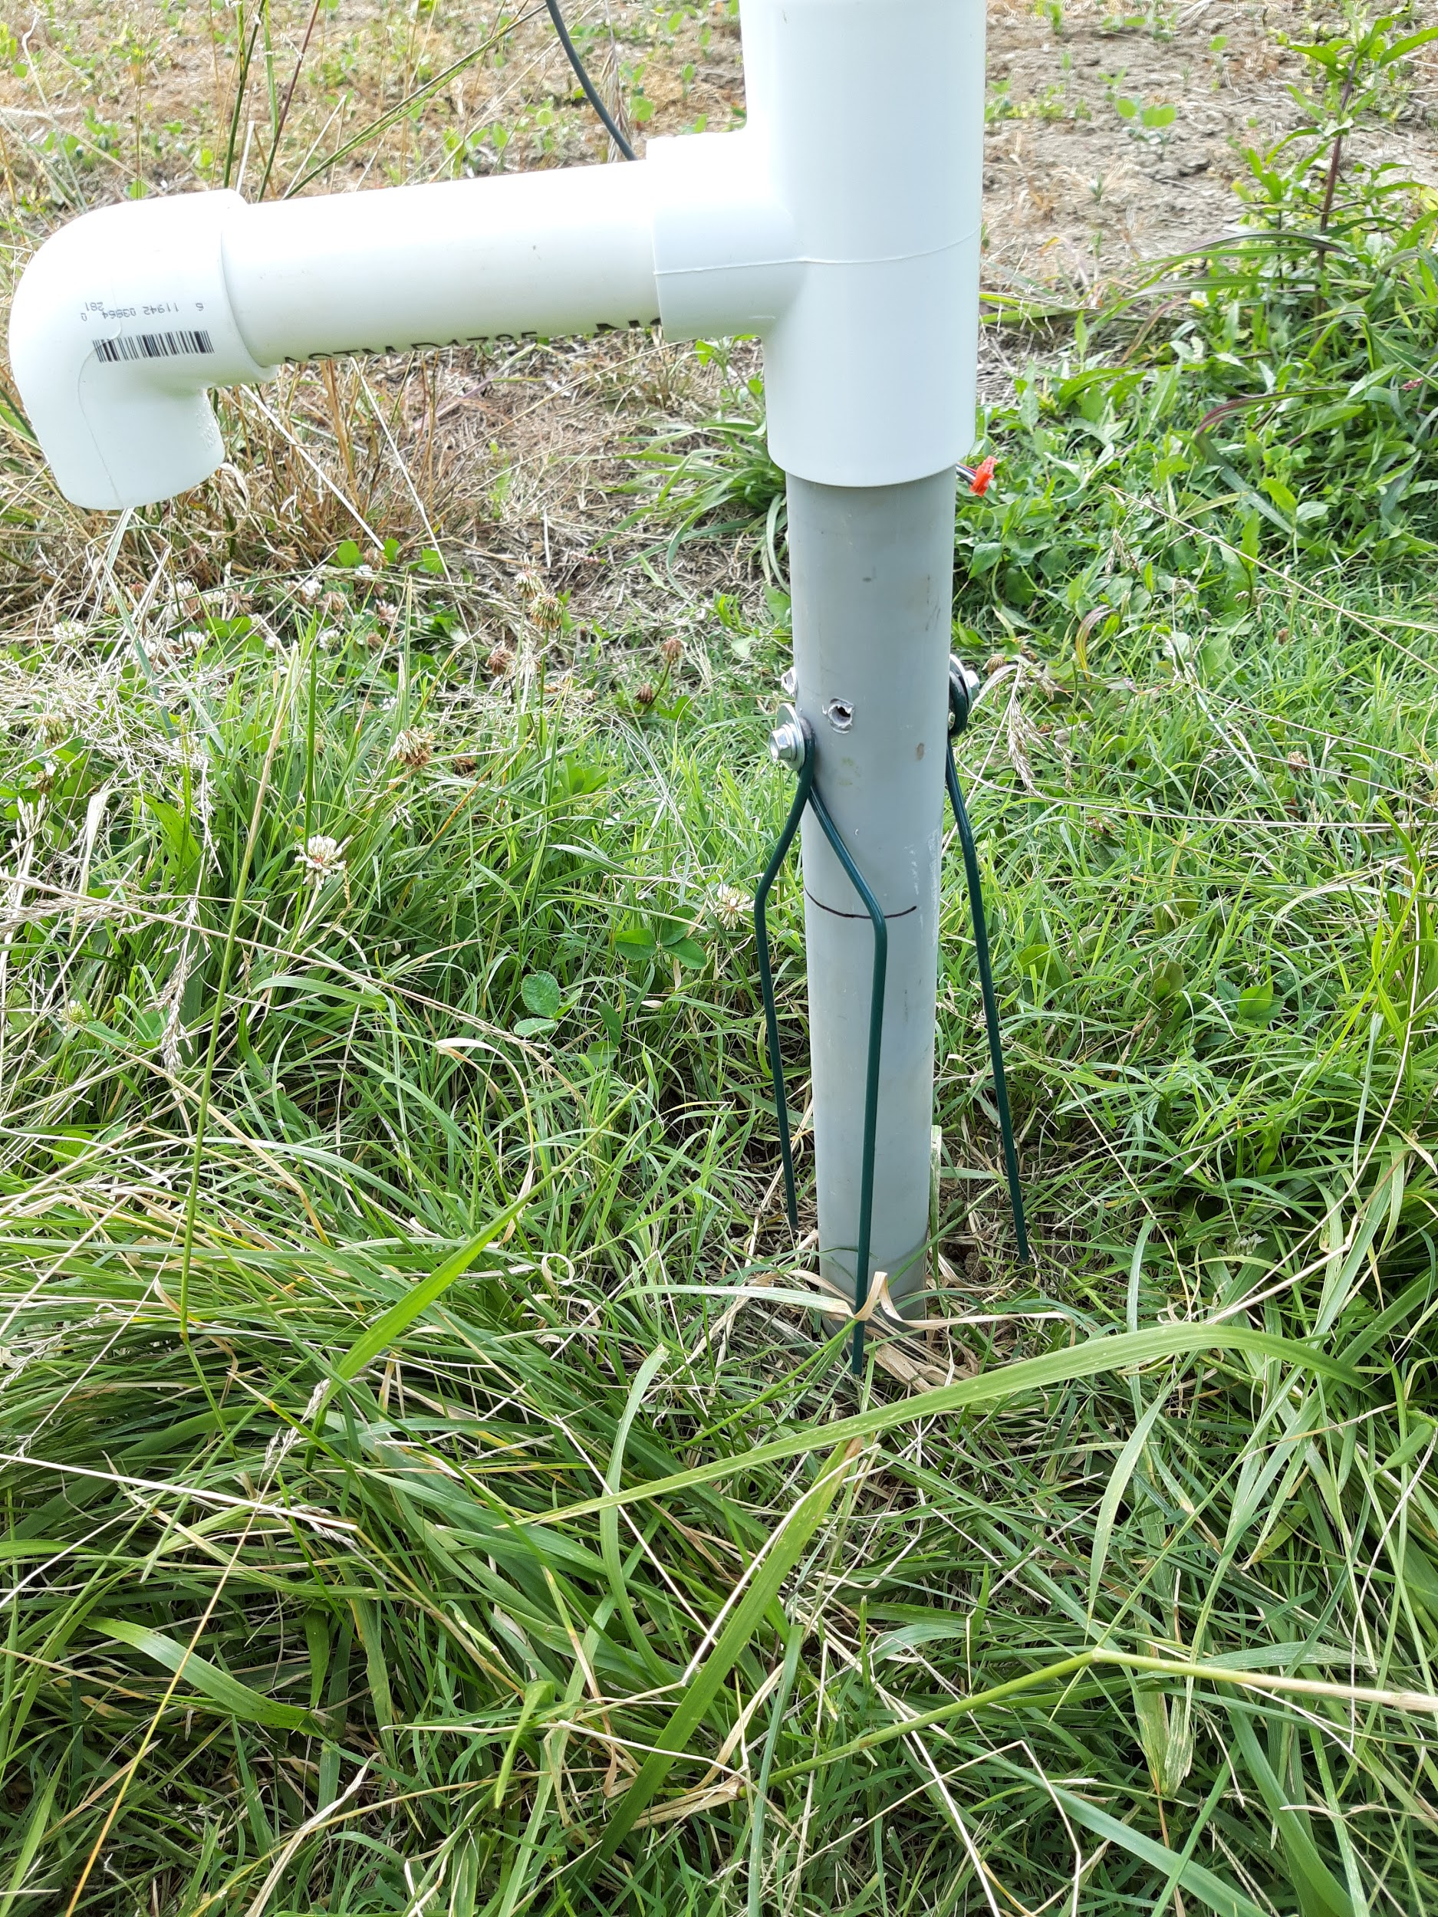

1. Adjust canopy sensor height with hook screw pin (helpful to have 2 people in case pivot PVC needs to be hammered in more).



(Note: we chose to have canopy sensor around 2’ above canopy at approximately a 65 degree angle from the horizontal to maximize the viewed area within our microplot (microplot dimensions: 15ft x 15ft [225 sq.ft]). At these constraints, the viewed area is about 25-30 square feet. We have a spreadsheet that calculates viewed area based on height above canopy, sensor angle, and sensor field of view. Let us know if you would like us to send it to you.)

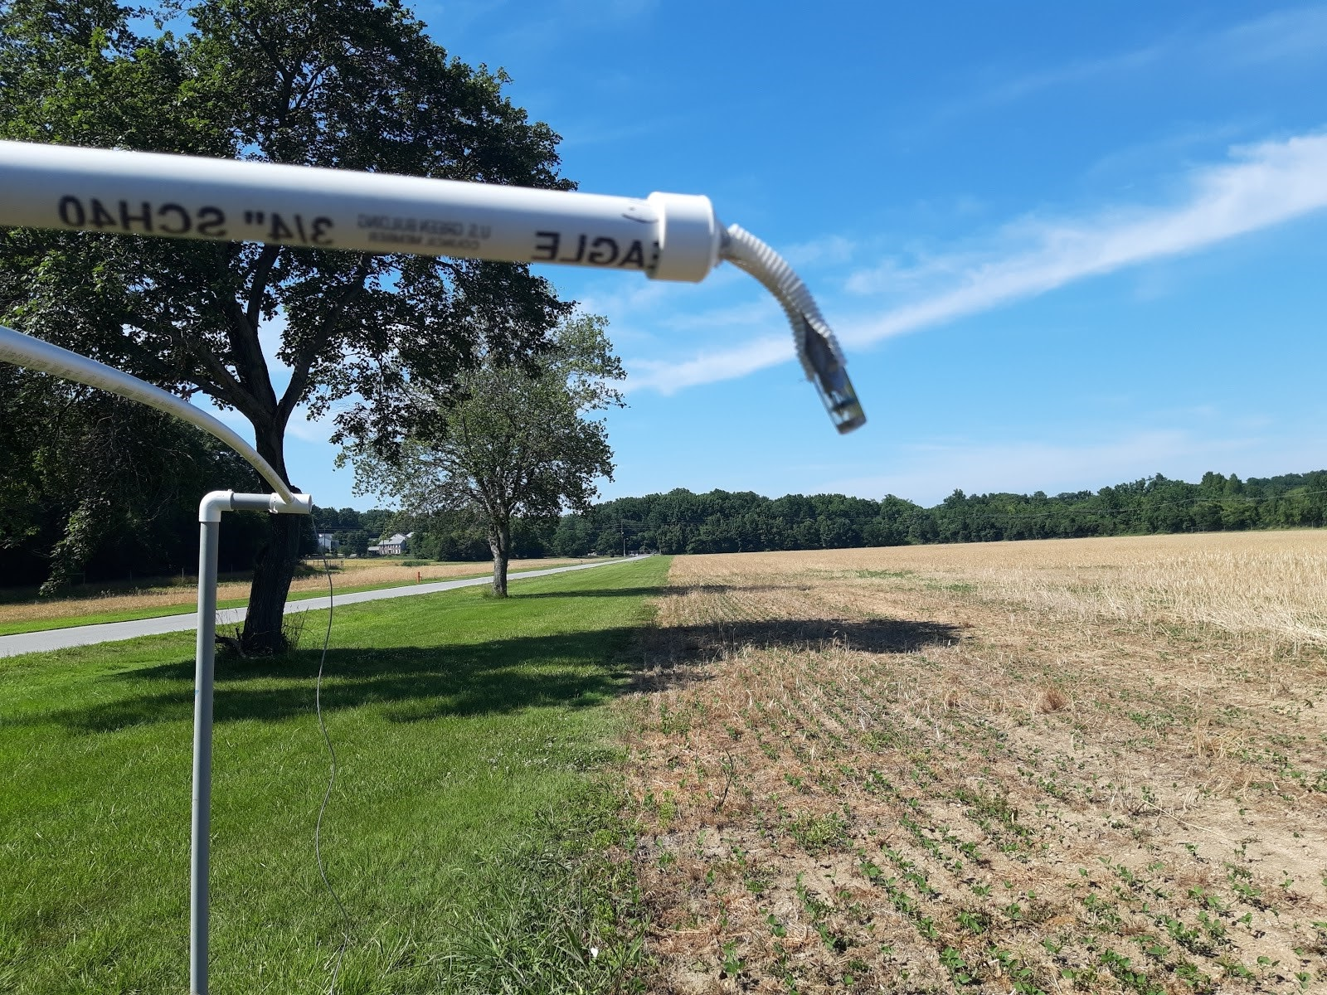

Canopy sensor tilted approximately 65 degrees

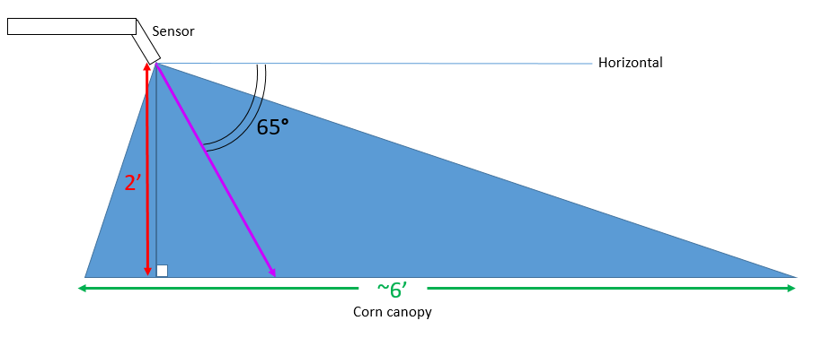

Side view diagram of sensor tilt and field of view

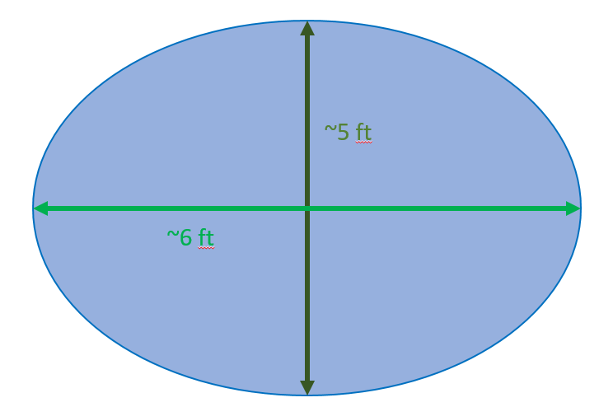

Top-down diagram of viewed area of sensor

1. Micro-adjust canopy sensor angle using long PVC as pictured: (we used ¾” PVC, put it over the sensor, and moved the sensor to the approximate angle/orientation)

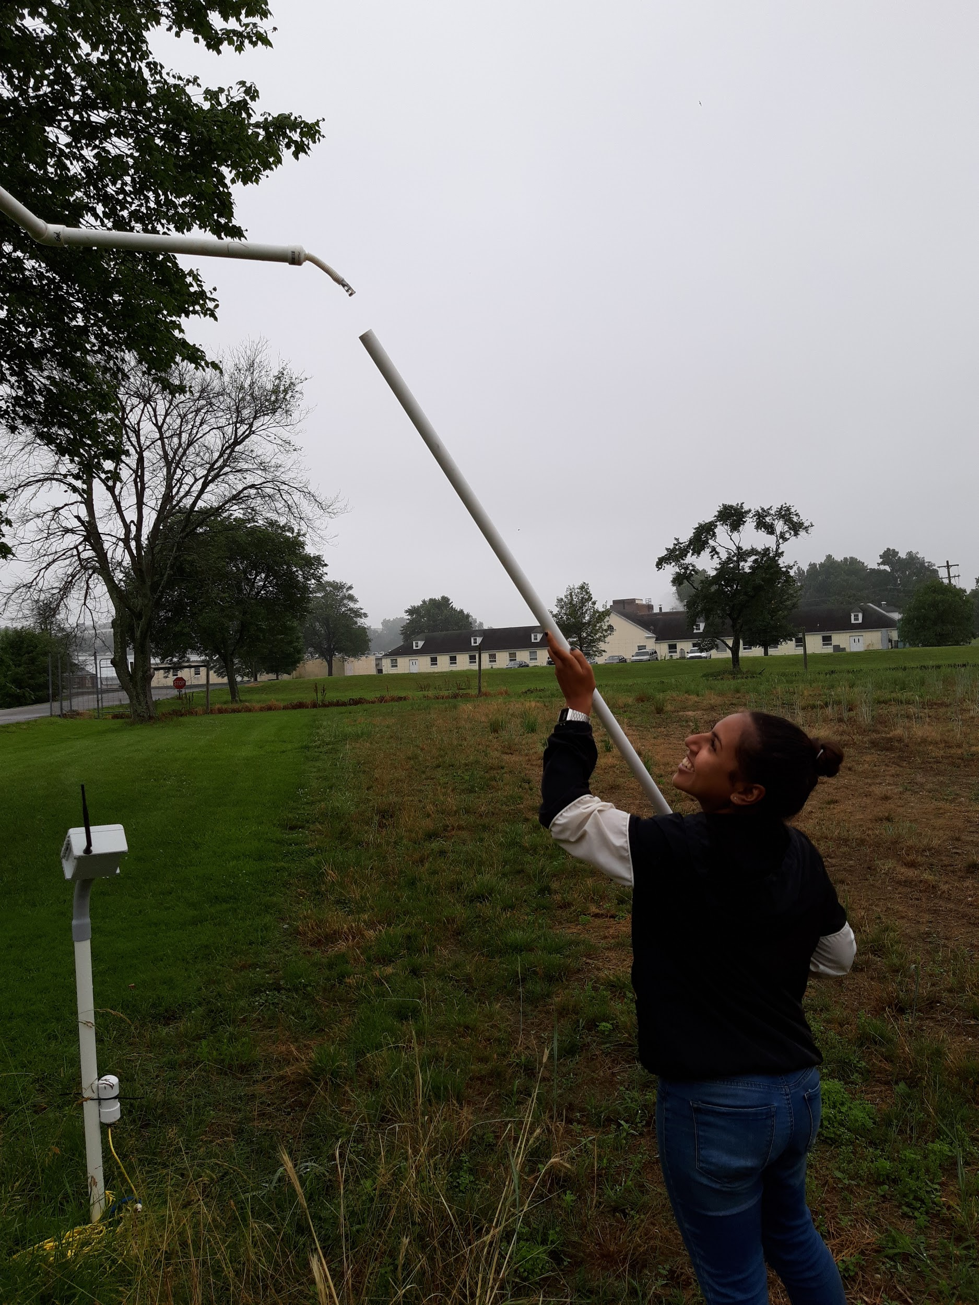

1. Wrap snake sensor around corn plant as pictured below and aim at leaf (1-4” from leaf):

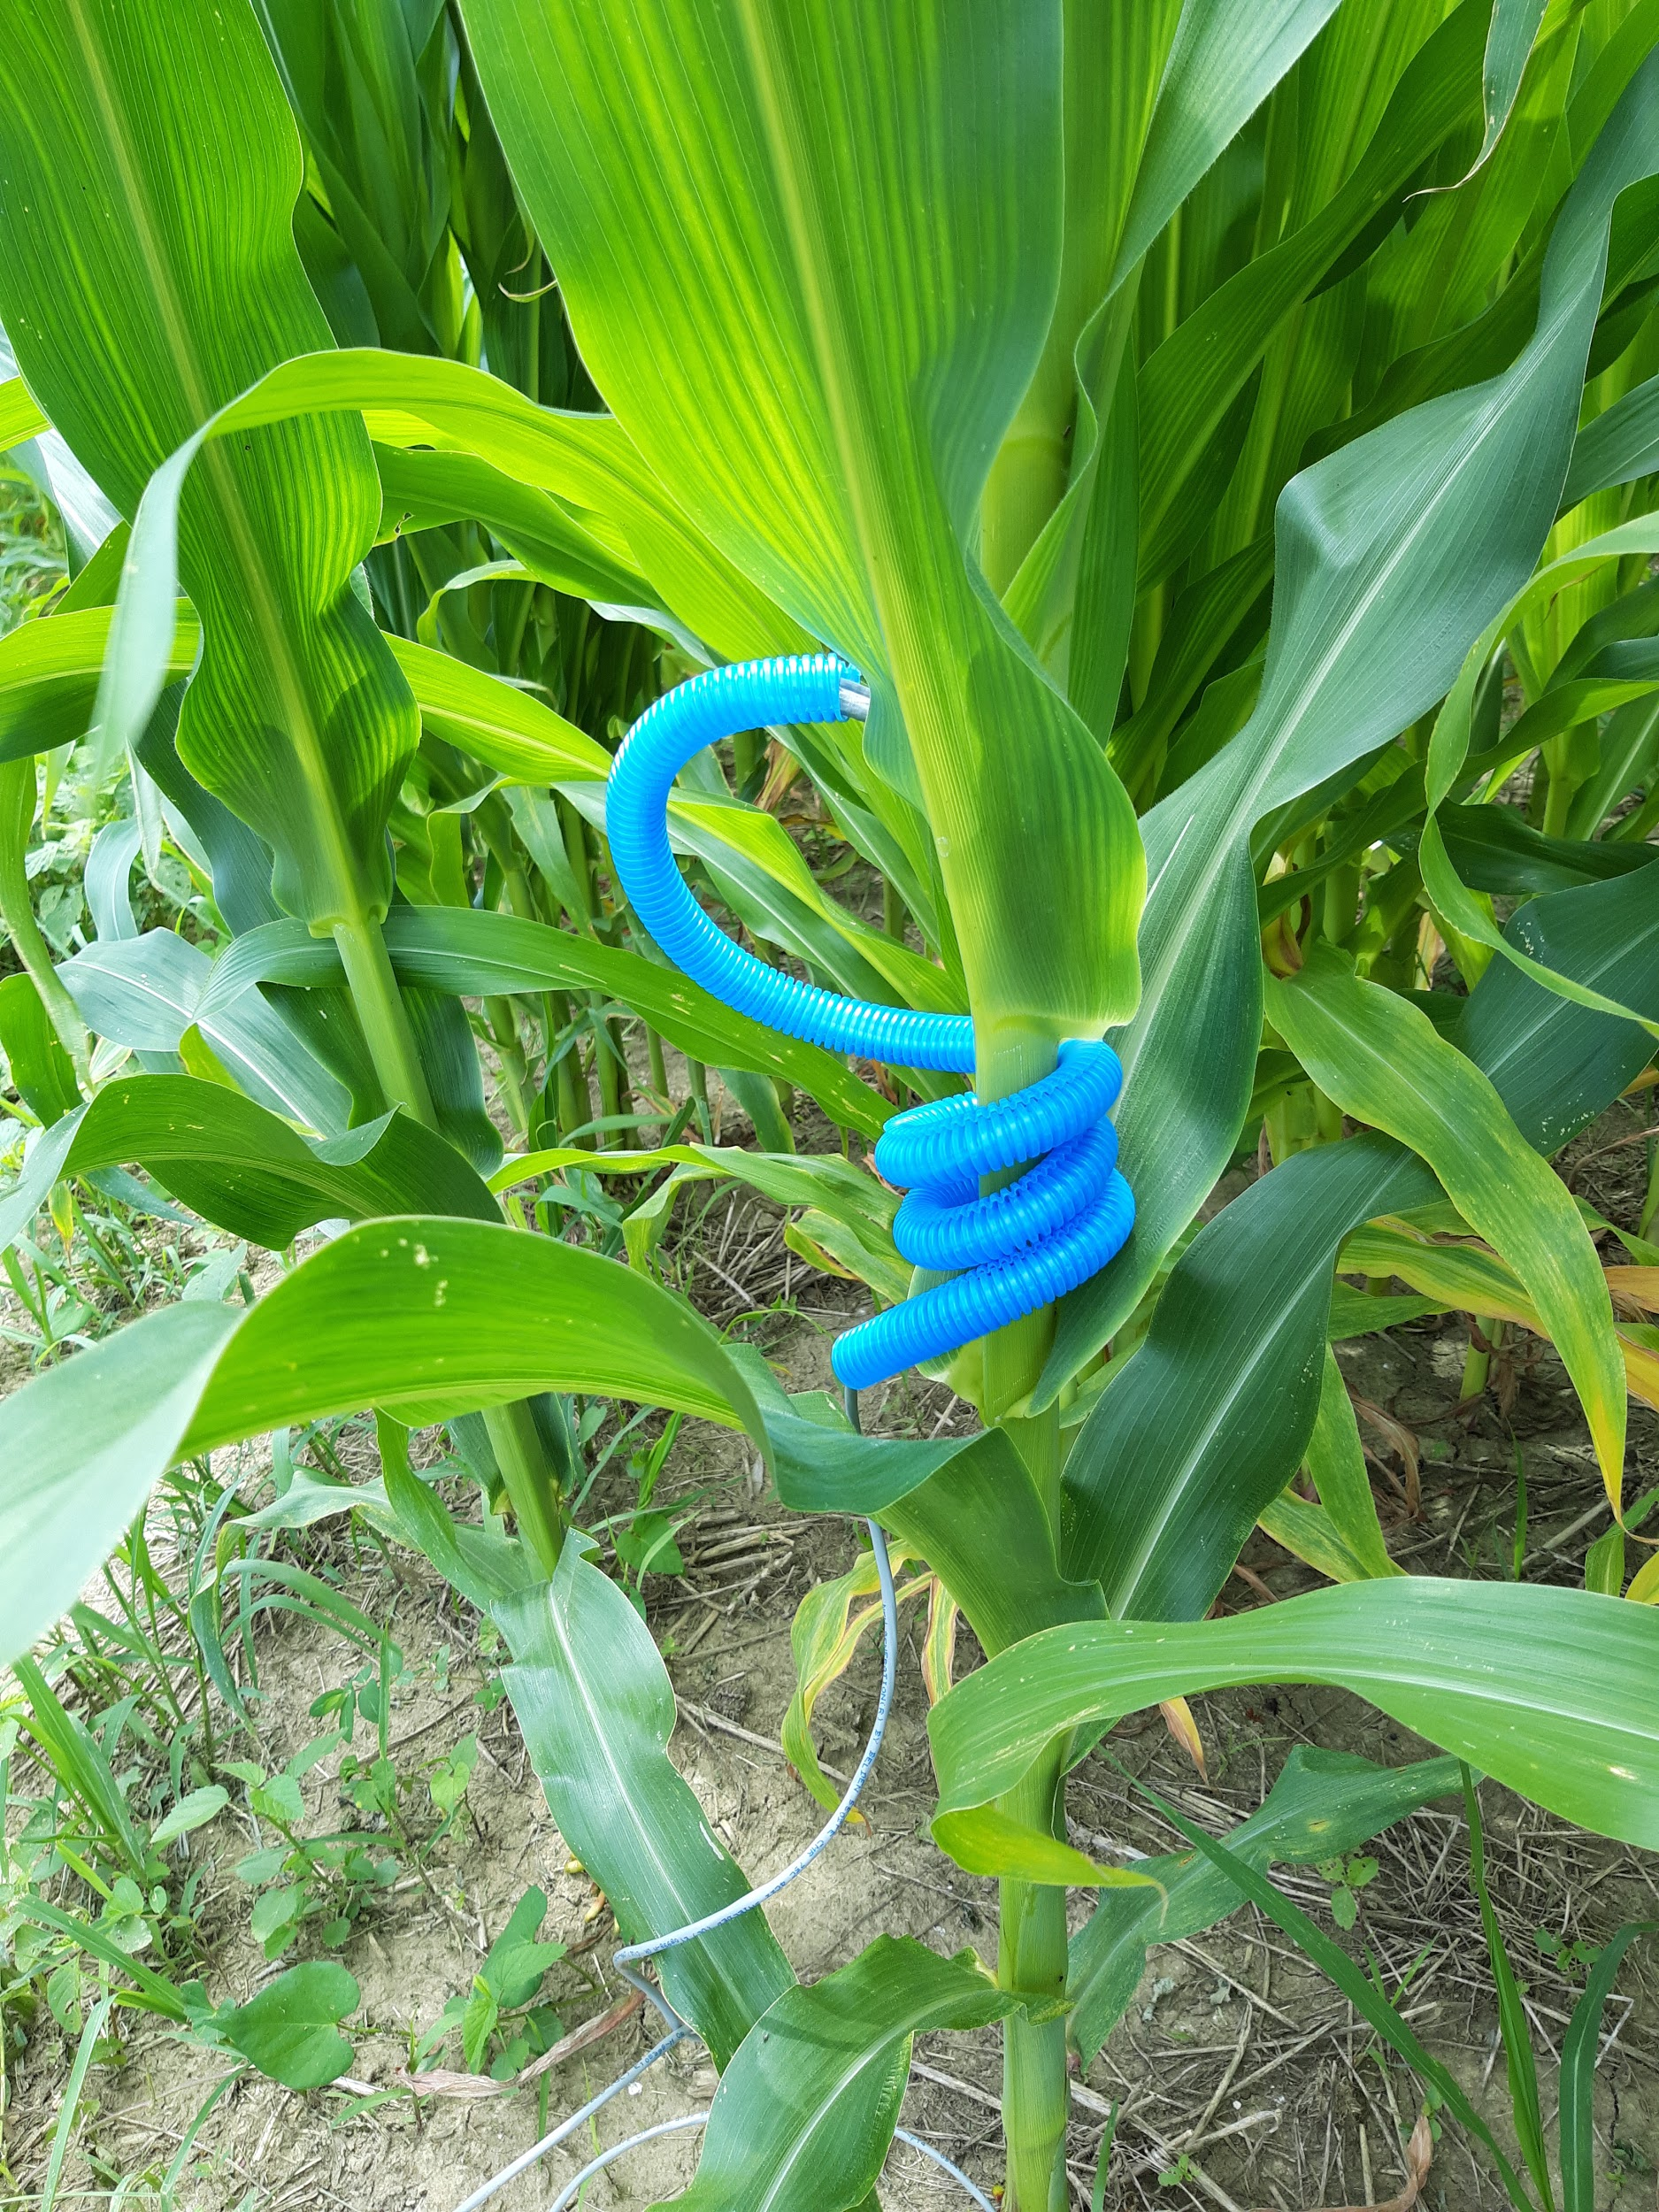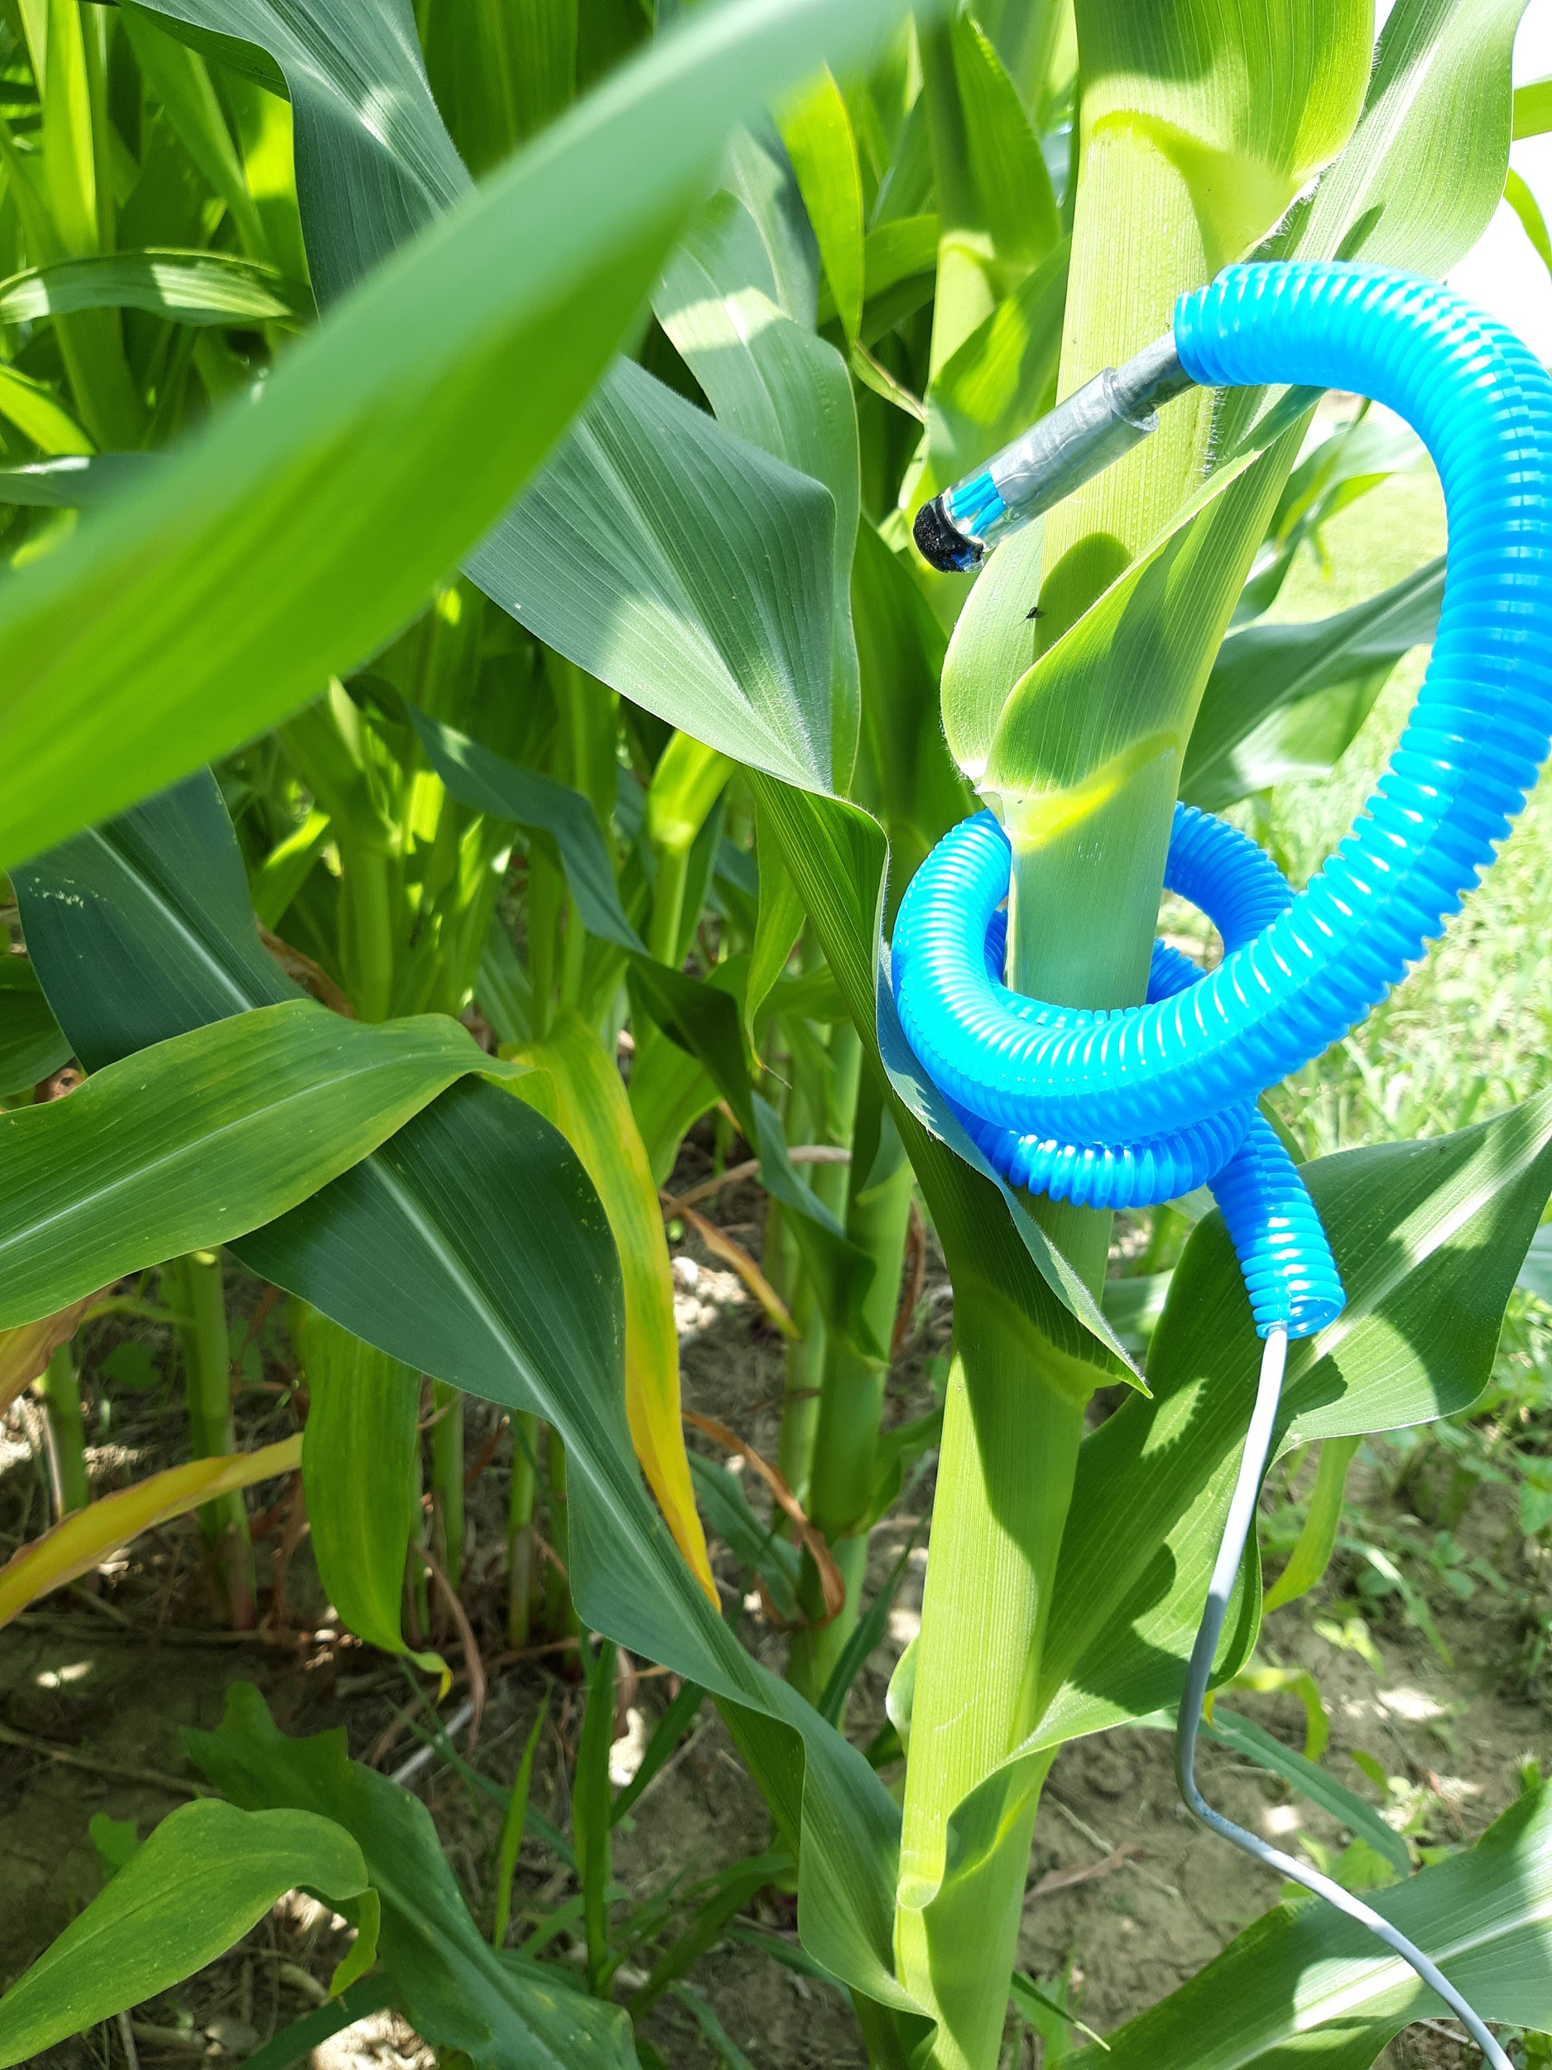

1. Attach enclosure to IRT structure. Pull sensor cables and power cable through enclosure and connect. Place desiccant packs inside enclosure for moisture absorption.

Note:

* If have to remove structure from field (for tilling, spraying, etc), may want **another 1-¼” PVC piece** for each structure to place in augered hole to hold its place until you put structure back